LOCAL AREA CHILD PROTECTION INDICATORS

INTRODUCTION
This report contains charts, tables and (optional) scrutiny questions to support analysis of the Minimum Dataset for Child Protection Committees. Other indicators of local importance (e.g. concerns, investigations, participation and outcomes data) have also been included as part of the report.

HEADLINE SUMMARY OF ACTIVITY LEVELS
The selected indicators below (number of children subject to initial/pre-birth Child Protection Case Conferences, newly registered, on the Register, and referred on non-offence grounds) provide an overview of activity levels.

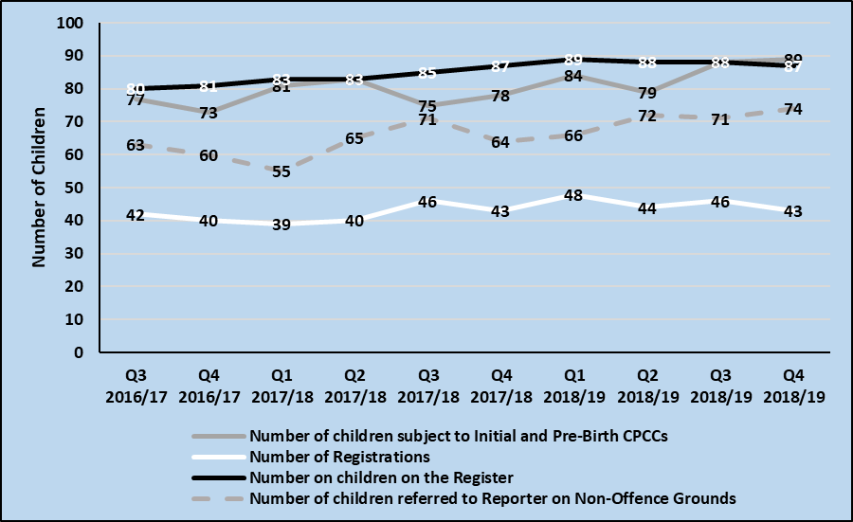

QUARTERLY REPORT: FEBRUARY TO APRIL 2019

HEADLINE MESSAGES
Once the multi-agency analysis of all indicators, charts and tables has been completed, review the analysis, commentary and implications and set out the headline messages that the Child Protection Committee should be made aware of:
- What notable trends or patterns exist?
- Have there been any notable changes in the last 1-2 quarters?
- What are the reasons/causes for any notable changes?
- What are the key implications for the Child Protection Committee?

INITIAL AND PRE-BIRTH CHILD PROTECTION CASE CONFERENCES

Number of Children Subject to Initial and Pre-Birth Child Protection Case Conference, and Conversion Rate of Children to Registration

Analysis and Commentary
Analysing the chart/table in the right hand column:
- What notable trends or patterns exist?
- Have there been any notable changes in the last 1-2 quarters?
- What are the reasons/causes for any notable changes – and can these reasons/causes be evidenced? If they cannot, what further understanding or analysis is needed?
- Are there any relationships between indicators?

Implications for the Child Protection Committee
- Where notable changes are identified, what is the ask of the Child Protection Committee? For example, ask for decision or approval to:
  - Undertake further, more detailed analysis of the statistical data and other (e.g. audit) activity.
  - Respond to specific scrutiny questions.
  - Take action in the form of increased monitoring, initiate new training programme, etc.

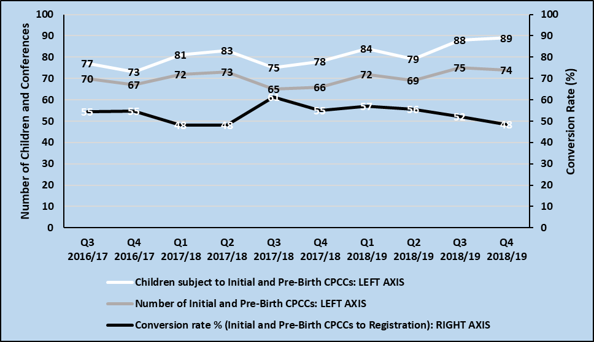
Source: Social Work IT System

Scrutiny questions to support analysis of the data:
- How do the number of children subject to conference compare to the number of children subject to earlier stages of the Child Protection process (e.g. number of children subject to concerns received by Social Work, number of children subject to investigations)?
- What is the conversion rate from Conference to Registration telling us – e.g. about thresholds?
- What are the reasons when children subject to conference are not registered; and are the needs of these children being met?

CHILD PROTECTION REGISTER, REGISTRATIONS, DE-REGISTRATIONS AND RE-REGISTRATIONS

Number of Children (including Pre-Birth) on the Child Protection Register, New Registrations, De-Registrations, and (see table) Re-Registrations within 3, 6, 12 and 24 months of de-registration

Analysis and Commentary
Analysing the chart/table in the right hand column:
- What notable trends or patterns exist?
- Have there been any notable changes in the last 1-2 quarters?
- What are the reasons/causes for any notable changes – and can these reasons/causes be evidenced? If they cannot, what further understanding or analysis is needed?
- Are there any relationships between indicators?

Implications for the Child Protection Committee
- Where notable changes are identified, what is the ask of the Child Protection Committee? For example, ask for decision or approval to:
  - Undertake further, more detailed analysis of the statistical data and other (e.g. audit) activity.
  - Respond to specific scrutiny questions.
  - Take action in the form of increased monitoring, initiate new training programme, etc.

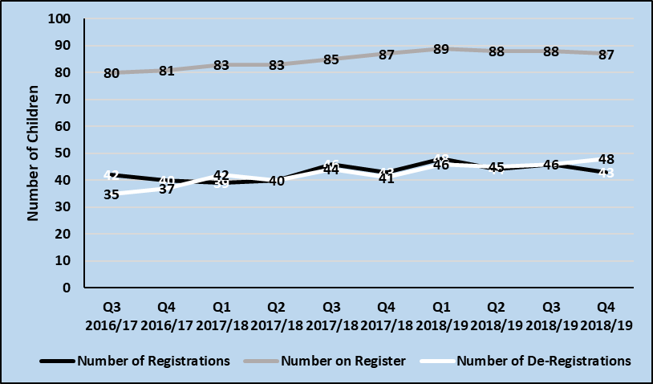
Source: Social Work IT System

Re-Registrations | 2016-2017 |  |  |  | 2017-2018 |  |  |  | Latest
 | Q1 | Q2 | Q3 | Q4 | Q1 | Q2 | Q3 | Q4 | Q1 | Q2 | Q3
3 months
6 months
12 months
24 months
Source: Social Work IT System (De-registration to re-registrations timescale)

Scrutiny questions to support analysis of the data:
- What are the characteristics of the children newly, re- and de-registered – and are they changing over time?
- For re-registrations, what has changed in their lives since de-registration, and what support(s) did they receive following de-registration?
- For children currently on the Child Protection Register, how long have they been on the Register?

CHARACTERISTICS OF OUR VULNERABLE CHILDREN AND YOUNG PEOPLE

Age of Children and Young People at Registration

Analysis and Commentary
Analysing the chart/table in the right hand column:
- What notable trends or patterns exist?
- Have there been any notable changes in the last 1-2 quarters?
- What are the reasons/causes for any notable changes – and can these reasons/causes be evidenced? If they cannot, what further understanding or analysis is needed?
- Are there any relationships between indicators?

Implications for the Child Protection Committee
- Where notable changes are identified, what is the ask of the Child Protection Committee? For example, ask for decision or approval to:
  - Undertake further, more detailed analysis of the statistical data and other (e.g. audit) activity.
  - Respond to specific scrutiny questions.
  - Take action in the form of increased monitoring, initiate new training programme, etc.

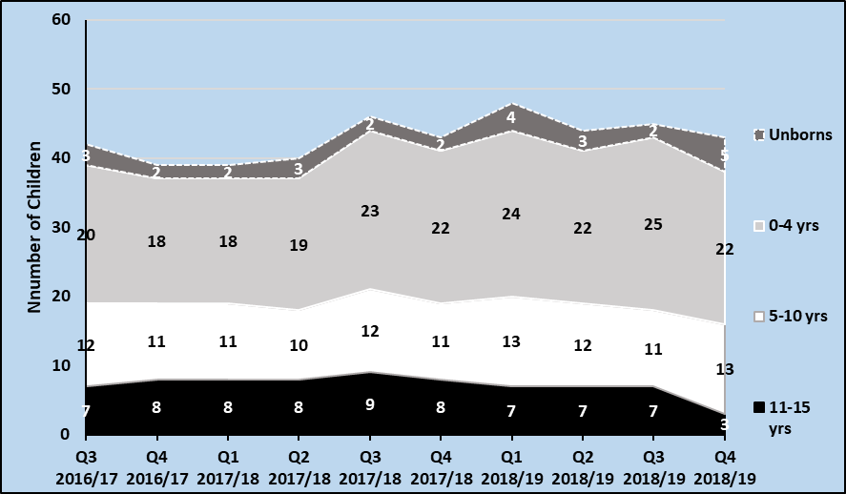
Source: Social Work IT System (16-17 year olds not presented)

Scrutiny questions to support analysis of the data:
- What factors explain any change(s) in the age profile? For example, improved awareness and identification of concerns among age-specific workforces; impact of a recent Significant Case Review; impact of wider social, economic or service-related factors; etc.?
- Does local service provision reflect the age profile (and development stage needs) of newly registered children?

Concerns recorded for Children and Young People at Registration

Analysis and Commentary
Analysing the chart/table in the right hand column:
- What notable trends or patterns exist?
- Has does the concerns profile locally compare with the Scotland annual data?
- Have there been any notable changes in the last 1-2 quarters?
- What are the reasons/causes for any notable changes – and can these reasons/causes be evidenced? If they cannot, what further understanding or analysis is needed?
- Are there any relationships between indicators?

Implications for the Child Protection Committee
- Where notable changes are identified, what is the ask of the Child Protection Committee? For example, ask for decision or approval to:
  - Undertake further, more detailed analysis of the statistical data and other (e.g. audit) activity.
  - Respond to specific scrutiny questions.
  - Take action in the form of increased monitoring, initiate new training programme, etc.

 | Aug 16–Jul 17 |  |  | Aug 17–Jul 18 |  | LOCAL
 | Local | Scot-land | Local |  | Scot-land | Aug - Oct 18 | Nov 18 - Jan 19 | Feb-Apr 19
Child Placing Themselves at Risk | 1% | 2% | % |  | 2% | % | % | %
CSE | 6% | 2% | % |  | 1% | % | % | %
Domestic Abuse | 28% | 37% | % |  | 37% | % | % | %
Emotional Abuse | 58% | 38% | % |  | 39% | % | % | %
Neglect | 44% | 36% | % |  | 39% | % | % | %
Non-Engaging Family | 45% | 24% | % |  | 25% | % | % | %
Parental Alcohol Misuse | 36% | 18% | % |  | 19% | % | % | %
Parental Drug Misuse | 21% | 26% | % |  | 37% | % | % | %
Parental Mental Health Problems | 35% | 30% | % |  | 33% | % | % | %
Physical Abuse | 35% | 18% | % |  | 21% | % | % | %
Sexual Abuse | 6% | 7% | % |  | 7% | % | % | %
Other (including Trafficking) | 8% | 11% | % |  | 15% | % | % | %
Total Number of Registrations | 181 | 2,715 |  |  | 2,668

Scrutiny questions to support analysis of the data:
- What factors explain any change(s) in the concerns profile? For example, genuine emergent concerns, training on specific concern(s) leading to increased identification, changes in how concerns are recorded, or impact of a recent Significant Case Review?
- Does local service provision reflect the most prevalent concerns identified?
- To what extent are parental concerns (e.g. domestic abuse; parental drug or alcohol misuse) shared with other Public Protection groupings to inform wider service planning?
SCOTTISH CHILDREN’S REPORTER ADMINISTRATION DATA
Children and Young People in the Children’s Hearing System – Referrals and (see table) Child Protection Orders Granted

Analysis and Commentary
Analysing the chart/table in the right hand column:
- What notable trends or patterns exist?
- Have there been any notable changes in the last 1-2 quarters?
- What are the reasons/causes for any notable changes – and can these reasons/causes be evidenced? If they cannot, what further understanding or analysis is needed?
- Are there any relationships between indicators?

Implications for the Child Protection Committee
- Where notable changes are identified, what is the ask of the Child Protection Committee? For example, ask for decision or approval to:
  - Undertake further, more detailed analysis of the statistical data and other (e.g. audit) activity.
  - Respond to specific scrutiny questions.
  - Take action in the form of increased monitoring, initiate new training programme, etc.

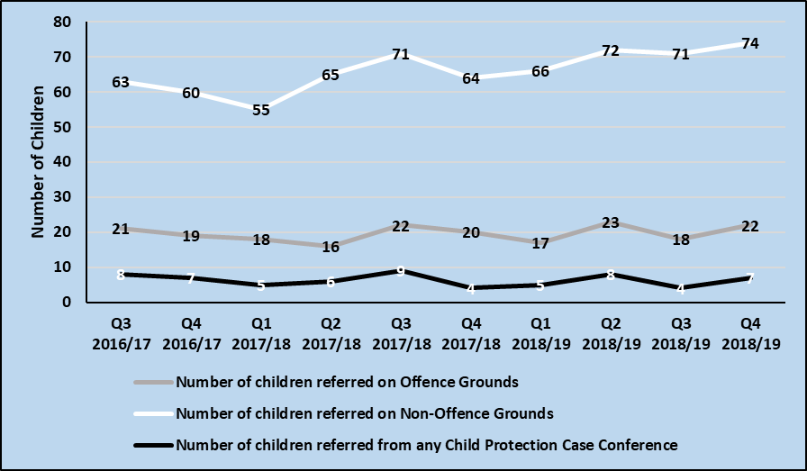
Source: SCRA

 | 2016-2017 |  |  |  | 2017-2018 |  |  |  | Latest
 | Q1 | Q2 | Q3 | Q4 | Q1 | Q2 | Q3 | Q4 | Q1 | Q2 | Q3
CPOs | 3 | 4 | 2 | 5 | 6 | 4 | 3 | 6 | 5 | 3

Scrutiny questions to support analysis of the data:
- What are the sources of the referrals to the Reporter (including whether from Child Protection Case Conference)?
- What are the detailed grounds for the referrals?
- How many and/or what proportion of Child Protection Orders were applied for but not granted? What were the reasons for them not being granted?

CHILD PROTECTION PROCESSES TIMESCALES IN THE NATIONAL GUIDANCE FOR CHILD PROTECTION IN SCOTLAND

Analysis and Commentary
Analysing the chart/table in the right hand column:
- What notable trends or patterns exist?
- Have there been any notable changes in the last 1-2 quarters?
- What are the reasons/causes for any notable changes – and can these reasons/causes be evidenced? If they cannot, what further understanding or analysis is needed?
- Are there any relationships between indicators?

Implications for the Child Protection Committee
- Where notable changes are identified, what is the ask of the Child Protection Committee? For example, ask for decision or approval to:
  - Undertake further, more detailed analysis of the statistical data and other (e.g. audit) activity.
  - Respond to specific scrutiny questions.
  - Take action in the form of increased monitoring, initiate new training programme, etc.

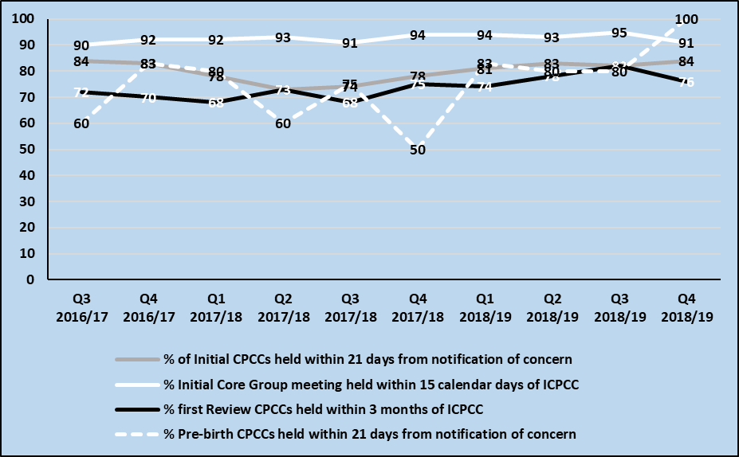
Source: Social Work IT System

Scrutiny questions to support analysis of the data:
- Where timescales are being met and/or are improving, what factors are contributing to this?
- Where timescales are not being met, what are the reasons for this? For example, are they due to delays that are in the child’s interests, or due to the availability of resources?
- When are subsequent Core Group meetings and Review Conferences scheduled, and are these being held as planned?
- What is the quality, and impact, of the Child’s Plans developed at these meetings?

PARENTAL OR CARER ATTENDANCE AT INITIAL CHILD PROTECTION CASE CONFERENCES AND INITIAL CORE GROUP MEETINGS

Analysis and Commentary
Analysing the chart/table in the right hand column:
- What notable trends or patterns exist?
- Have there been any notable changes in the last 1-2 quarters?
- What are the reasons/causes for any notable changes – and can these reasons/causes be evidenced? If they cannot, what further understanding or analysis is needed?
- Are there any relationships between indicators?

Implications for the Child Protection Committee
- Where notable changes are identified, what is the ask of the Child Protection Committee? For example, ask for decision or approval to:
  - Undertake further, more detailed analysis of the statistical data and other (e.g. audit) activity.
  - Respond to specific scrutiny questions.
  - Take action in the form of increased monitoring, initiate new training programme, etc.

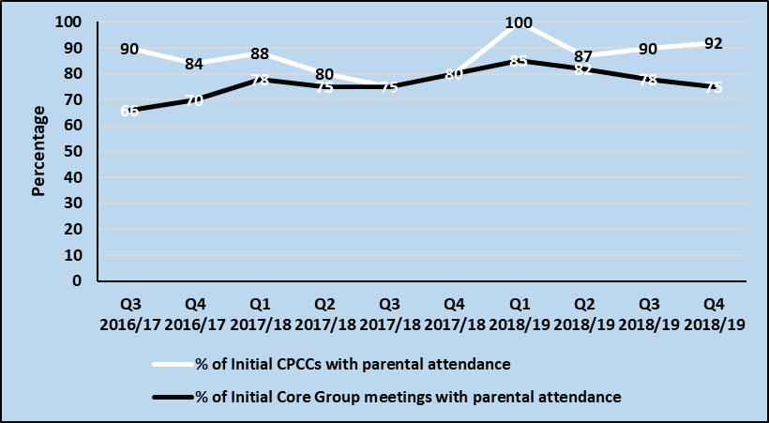
Source: Social Work IT System

Scrutiny questions to support analysis of the data:
- Where there was no parental attendance, what were the reasons for this?
- Are the parents where the risk lies and/or who need to change their behaviour attending?
- To what extent are parents active contributors to the meetings – i.e. what is the quality of their participation?
- How are services engaging non-attending parents with child protection planning?
- What was the level of professional attendance and participation at meetings?

REPORTER DECISIONS WITHIN 50 WORKING DAYS OF REFERRAL RECEIPT

Analysis and Commentary
Analysing the chart/table in the right hand column:
- What notable trends or patterns exist?
- Have there been any notable changes in the last 1-2 quarters?
- What are the reasons/causes for any notable changes – and can these reasons/causes be evidenced? If they cannot, what further understanding or analysis is needed?
- Are there any relationships between indicators?

Implications for the Child Protection Committee
- Where notable changes are identified, what is the ask of the Child Protection Committee? For example, ask for decision or approval to:
  - Undertake further, more detailed analysis of the statistical data and other (e.g. audit) activity.
  - Respond to specific scrutiny questions.
  - Take action in the form of increased monitoring, initiate new training programme, etc.

 | 2016-2017 |  |  |  | 2017-2018 |  |  |  | Latest
 | Q1 | Q2 | Q3 | Q4 | Q1 | Q2 | Q3 | Q4 | Q1 | Q2 | Q3
50 days Reporter Decision | 74 | 75 | 80 | 79 | 82 | 81 | 90 | 83 | 85 | 90
Source: SCRA (percentage of decisions within 50 working days of referral)

Scrutiny questions to support analysis of the data:
- Given the national target that 78% of decisions are made by the Reporter within 50 working days of referral receipt, how do timescales locally compare?
- Where the target is being met and/or is improving, what factors are contributing to this?
- Where the target is not being met, what are the reasons for this? For example, are they due to delays that are in the child’s interests, or due to the availability of resources?

APPENDIX 1: ANNUAL NATIONAL TO LOCAL BENCHMARKS, AUGUST 2017 – JULY 2018

 | Local | Scotland
Indicator 1: Rate of children subject to Initial and Pre-Birth Child Protection Case Conference per 1,000 children
Indicator 2: Conversion Rate of Children from Initial and Pre-Birth Child Protection Case Conference to Registration
Indicator 3: Rate of Registrations per 1,000 children
Indicator 4: Rate of Re-Registrations (within 24 months) per 1,000 children |  | 0.4
Indicator 5: Rate of Children on the Register per 1,000 children |  | 2.8
Indicator 6: Rate of De-Registrations per 1,000 children |  | 4.8
Characteristics of Our Vulnerable Children and Young People
Indicator 7: % of registrations by age of child:  - Unborn  - 0-4 years old  - 5-10 years old  - 11-15 years old  - 16-17 years old | - %  - %  - %  - %  - % | - 4%  - 46%  - 33%  - 16%  - 1%
Indicator 8: % of registrations by concerns | See Report Table
Police Scotland
Indicators 9-10 | TBC | TBC
Children’s Hearing System
Indicator 11A: Rate referred on Offence grounds per 1,000 children |  | 3.3
Indicator 11B: Rate referred on Non-Offence grounds per 1,000 children |  | 12.3
Indicator 12: Referrals from a Child Protection Case Conference | NA | NA
Indicator 13: Rate of Child Protection Orders granted per 1,000 children |  | 0.7
Assessing Local Response and Child Protection Processes
Indicator 14: % of Initial Child Protection Case Conferences held no later than 21 calendar days from notification of concern
Indicator 15: % of Pre-Birth Child Protection Case Conferences taking place no later than at 28 weeks pregnancy or, in the case of late notification of pregnancy as soon as possible, and in any case within 21 calendar days
Indicator 16: % of Initial Core Group meetings held within 15 calendar days of the Initial Child Protection Case Conference
Indicator 17: % of First Review Child Protection Case Conferences held within 3 months of the Initial Child Protection Case Conference
Indicator 18A: % of Initial Child Protection Case Conferences with parental attendance
Indicator 18B: % of Initial Core Group meetings with parental attendance
Indicator 19: % of Reporter's decisions made within 50 working days of referral receipt |  | 76%
Note: ‘Children’ defined as 0-15 year olds; SCRA data refers to April-March 2017-2018 data

APPENDIX 2: LOCAL CHILD PROTECTION PROCESS ADD LOCAL MAP
The diagram below shows the local children protection process, noting that many of the Minimum Dataset indicators report on key stages of this process.

