Introduction
In June 2020 CELCIS produced the first Lifelong Links Briefing, outlining the ongoing evaluation of Lifelong Links in Scotland. In it, we presented some of the initial topics that were emerging from the data we had received or collected. The aim was to help local sites and Family Rights Group to continue to develop their practice and improve the lives of children and young people in Scotland.
In this follow up Briefing, we highlight some of the new things we have been hearing, focusing on the impact that the COVID-19 public health emergency has had on Lifelong Links. These are by no means conclusive and are simply indications of topics, which have been raised by participants. We will also provide an update on the overall evaluation activities in Scotland and outline what we hope to achieve between now and the evaluation ending in March 2023.
Since our last Briefing, a report detailing the English evaluation of Lifelong Links by the Rees Centre at the University of Oxford, and published by the Department for Education, is now available.

What is Lifelong Links?
Lifelong Links is an innovative approach to supporting children and young people who are looked after away from their parents and their families. It was developed by Family Rights Group to address concerns about how networks of children who are looked after can become fragmented, impacting upon their sense of belonging and identity. The Lifelong Links approach aims to improve both experiences and outcomes for children and young people.
The Lifelong Links process works to identify and engage relatives and other supportive adults, including those who have become distant, or are not yet known to the child or young person. Lifelong Links has a set of tools and techniques that professionals can use to search for and find family members (known and unknown) and other adults (such as former foster carers and teachers) who care about the child. This network of people is then brought together in a family group conference (also known as family group decision making) to make a support plan with the child or young person.
By identifying adults who are willing to make a life-long commitment to the child or young person, Lifelong Links aims to increase their sense of permanence, security and wellbeing.

It is hoped the resulting continuity and permanence of relationships (be it with relatives or others connected to the child or young person) will provide ongoing support, an explanation of historical events, and reinforce identity, belonging and a sense of self.

The Evaluation
Lifelong Links is currently being trialled in five Scottish local authorities, three of whom are taking part in the Scottish Evaluation. Working collaboratively with colleagues from the Rees Centre (based at the University of Oxford) and Family Rights Group, CELCIS has developed and conducted the evaluation of the Lifelong Links model in Scotland.
The Scottish evaluation of Lifelong Links is a five-year, mixed method longitudinal evaluation running from 2018 to 2023. The evaluation uses two main types of data: ‘child level data’ and ‘qualitative data’.
Through the collection and analysis of this data, we hope to find out:
- To what extent did Lifelong Links achieve the intended outcomes?
- What helped or hindered the achievement of these outcomes?
- How is Lifelong Links carried out and experienced by those involved?
- What helped or hindered the use of Lifelong Links in Scottish sites?
- What enables or limits longer-term sustainability?
Through the course of the COVID-19 pandemic, we have had to change our data collection methods to make sure that we comply with all restrictions and prioritise the safety of children and young people, families, and staff taking part in Lifelong Links activities. Over the last year, we have been using telephone and virtual methods, such as Zoom and Microsoft Teams, to ensure we can continue to collect data for the evaluation.

What we have learned about Lifelong Links and COVID-19
Since 2020, we have undertaken more focus groups and interviews with Lifelong Links coordinators, Lifelong Links managers, foster carers, and one young person. Through gathering this data and hearing about people’s experiences, we have been able to understand the impact of the COVID-19 public health emergency on children, young people, and their families. We have also been able to gain an insight into the ways that Lifelong Links practice adapted in the context of local and national restrictions.
During the initial lockdown, which began in March 2020, local sites had to pause some of their Lifelong Links work so that staff members could be redeployed to help deal with crises caused by the pandemic. Since then, activities have resumed in all three local sites involved in the evaluation, adapting to the restrictions

placed on meeting people from other households. Now that Lifelong Links activities have resumed, workers engage with children and young people online, using applications such as Microsoft Teams and WhatsApp. This is in contrast to the face-to-face, hands-on work that children and young people usually do with Lifelong Links workers.
We know that the move to online working has been challenging for everyone working with children and young people. For instance, research has highlighted that access to online tools varies substantially, with digital inequality a serious problem throughout the pandemic. Staff members working in children’s services and young people themselves may have significant gaps in digital skills and literacy, with access to devices a particular problem for some children and young people.
Below we have highlighted some initial insights that seem to be emerging from the data we have collected about the impact of the COVID-19 pandemic on Lifelong Links. These are by no means conclusive and are indications of topics which have been raised by participants.
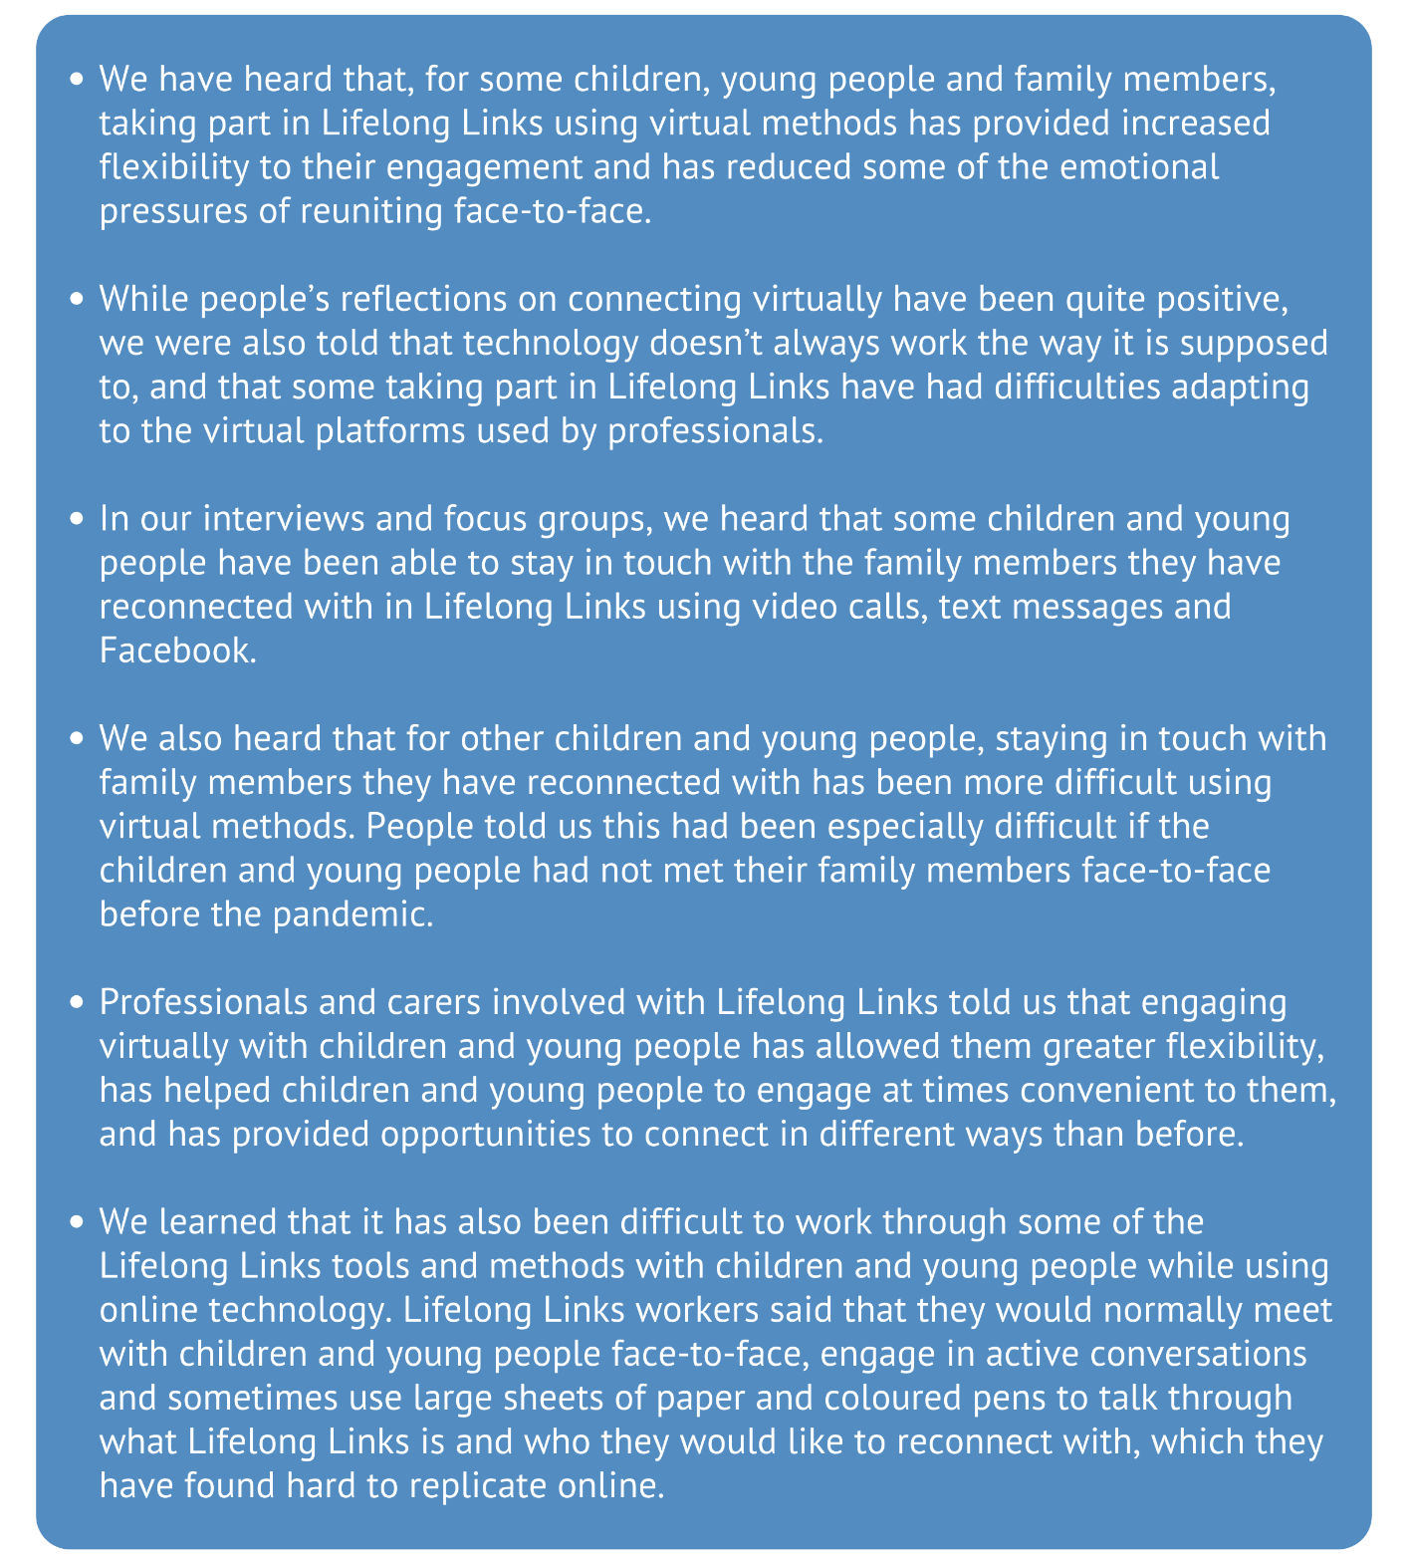

Looking ahead
The Lifelong Links evaluation will continue until March 2023, when CELCIS will publish their final project report. It is likely that the COVID-19 pandemic will continue to inform the work of Lifelong Links teams and to feature in the data collected for the Scottish evaluation. The increased pressure on social services, and the anticipated long-term impacts on the lives of children and young people, mean that we may face challenges collecting some data. Living through the pandemic has been a difficult experience for many people living across the world. We expect to learn more about how the pandemic has impacted on referrals to Lifelong Links and the future outcomes of the trial.
We anticipate that there will be continued disruption to data collection for the evaluation caused by COVID-19 restrictions. While we look forward to resuming face-to-face data collection when it is safe to do so, in the meantime, we will continue to collect qualitative data using telephone and virtual methods. This will enable us to keep on learning about the impacts the Lifelong Links trial is having for children, young people and families in Scotland.

